**VIVEKANAND EDUCATION SOCIETY’S INSTITUTE OF TECHNOLOGY**

**Department of Computer Engineering**



Project Report on

Blockchain Based Medicine Ordering System using IVR

In partial fulfilment of the Fourth Year, Bachelor of Engineering (B.E.) Degree in Computer Engineering at the University of Mumbai

Academic Year 2024-25

**Submitted by**

Aditya Kushwaha - D17A - 35

Lintomon Chirakkara - D17A - 08

Chinmay Phapale- D17A - 46

Vedant Talwalkar - D17A - 61

**Project Mentor**

Prof. Richard Joseph

(2024-25)

**VIVEKANAND EDUCATION SOCIETY’S INSTITUTE OF TECHNOLOGY**

**Department of Computer Engineering**



**Certificate**

This is to certify that **Aditya Kushwaha(D17A, 35),Lintomon Chirakkara(D17A, 08), Chinmay Phapale(D17A, 46), Vedant Talwalkar(D17A, 61*)*** of Fourth Year Computer Engineering studying under the University of Mumbai have satisfactorily completed the project on “**Blockchain Based Medicine Ordering System using IVR**” as a part of their coursework of PROJECT-II for Semester-VIII under the guidance of their mentor **Prof. Richard Joseph** in the year 2024-25 .

This project report entitled **Blockchain Based Medicine Ordering System using IVR** by ***Aditya Kushwaha, Lintomon Chirakkara Chinmay Phapale, Vedant Talwalkar*** is approved for the degree of **B.E. Computer Engineering.**

| Programme Outcomes | Grade |
| --- | --- |
| PO1,PO2,PO3,PO4,PO5,PO6,PO7, PO8, PO9, PO10, PO11, PO12  PSO1, PSO2 |  |

Date:

Project Guide:

------------------------------------------

**Project Report Approval**

**For**

**B. E (Computer Engineering)**

This project report entitled **Blockchain Based Medicine Ordering System using IVR** by ***Aditya Kushwaha, Lintomon Chirakkara Chinmay Phapale, Vedant Talwalkar*** is approved for the degree of **B.E. Computer Engineering.**

| -----------------------------------------  Internal Examiner | -----------------------------------------  External Examiner |
| --- | --- |
| -----------------------------------------  Head of Department | -----------------------------------------  Principal |

Date:

Place: Mumbai

**Declaration**

We declare that this written submission represents our ideas in our own words and where others' ideas or words have been included, we have adequately cited and referenced the original sources. We also declare that we have adhered to all principles of academic honesty and integrity and have not misrepresented or fabricated or falsified any idea/data/fact/source in our submission. We understand that any violation of the above will be cause for disciplinary action by the Institute and can also evoke penal action from the sources which have thus not been properly cited or from whom proper permission has not been taken when needed.

| -----------------------------------------  (Lintomon Chirrakara D17A/08) | -----------------------------------------  (Aditya Kushwaha D17A/35) |
| --- | --- |
| -----------------------------------------  (Chinmay Phapale D17A/46) | -----------------------------------------  (Vedant Talwalkar D17A/61) |

Date:

**ACKNOWLEDGEMENT**

We are thankful to our college Vivekanand Education Society’s Institute of Technology for considering our project and extending help at all stages needed during our work of collecting information regarding the project.

It gives us immense pleasure to express our deep and sincere gratitude to Assistant Professor **Mr. Richard Joseph (Project Guide)** for his kind help and valuable advice during the development of project synopsis and for her guidance and suggestions.

We are deeply indebted to Head of the Computer Department **Dr.(Mrs.) Nupur Giri** and our **Principal Dr. (Mrs.) J.M. Nair** , for giving us this valuable opportunity to do this project.

We express our hearty thanks to them for their assistance without which it would have been difficult in finishing this project synopsis and project review successfully.

We convey our deep sense of gratitude to all teaching and nonteaching staff for their constant encouragement, support and selfless help throughout the project work. It is a great pleasure to acknowledge the help and suggestion, which we received from the Department of Computer Engineering.

We wish to express our profound thanks to all those who helped us in gathering information about the project. Our families too have provided moral support and encouragement several times.

**Computer Engineering Department**

**COURSE OUTCOMES FOR B.E PROJECT**

Learners will be to,

| **Course**  **Outcome** | **Description of the Course Outcome** |
| --- | --- |
| CO 1 | Able to apply the relevant engineering concepts, knowledge and skills towards the project. |
| CO2 | Able to identify, formulate and interpret the various relevant research papers and to determine the problem. |
| CO 3 | Able to apply the engineering concepts towards designing solutions for the problem. |
| CO 4 | Able to interpret the data and datasets to be utilised. |
| CO 5 | Able to create, select and apply appropriate technologies, techniques, resources and tools for the project. |
| CO 6 | Able to apply ethical, professional policies and principles towards societal, environmental, safety and cultural benefit. |
| CO 7 | Able to function effectively as an individual, and as a member of a team, allocating roles with clear lines of responsibility and accountability. |
| CO 8 | Able to write effective reports, design documents and make effective presentations. |
| CO 9 | Able to apply engineering and management principles to the project as a team member. |
| CO 10 | Able to apply the project domain knowledge to sharpen one’s competency. |
| CO 11 | Able to develop a professional, presentational, balanced and structured approach towards project development. |
| CO 12 | Able to adopt skills, languages, environment and platforms for creating innovative solutions for the project. |

**Index**

| Chapter No. | Title | Page  No. |
| --- | --- | --- |
| **1** | **Introduction** | 11 |
| 1.1 | Introduction to the project | 11 |
| 1.2 | Motivation for the project | 11 |
| 1.3 | Problem Definition | 11 |
| 1.4 | Existing Systems | 12 |
| 1.5 | Lacuna of the Existing Systems | 12 |
| 1.6 | Relevance of the Project | 12 |
| **2** | **Literature Survey** | 13 |
| A | Brief overview of Literature Survey | 13 |
| 2.1 | Research Papers  a. Abstract of the research paper  b. Inference drawn from the paper | 13 |
| 2.2 | Patent search  a. Title of the patent and year of the patent  b. Summary of the patent  c. Link 1. European Patent: http://worldwide.espacenet.com/, Link 2. Google Patents: https://patents.google.com/ | 19 |
| 2.3 | Inference Drawn | 20 |
| 2.4 | Comparison with the Existing Systems | 20 |
| **3.** | **Requirement Gathering for the proposed System** | 21 |
| 3.1 | Introduction to Requirement Gathering | 21 |
| 3.2 | Functional Requirements | 22 |
| 3.3 | Non-Functional Requirements | 22 |
| 3.4 | Hardware, Software, Technology and tools utilised | 22 |
| 3.5 | Constraints | 24 |
| **4.** | **Proposed Design** | 25 |
| 4.1 | Block diagram of the system | 25 |
| 4.2 | Modular design of the system | 26 |

6

| 4.3 | Detailed Design (Flowchart) | 28 |
| --- | --- | --- |
| 4.4 | Project Scheduling &amp; Tracking using Timeline / Gantt Chart | 29 |
| **5.** | **Implementation of the Proposed System** | 30 |
| 5.1 | Methodology employed for development | 30 |
| 5.2 | Algorithms and flowcharts for the respective modules developed | 31 |
| 5.3 | Datasets source and utilisation | 33 |
| **6.** | **Testing of the Proposed System** | 35 |
| 6.1 | Introduction to testing | 35 |
| 6.2 | Types of tests Considered | 35 |
| 6.3 | Various test case scenarios considered | 36 |
| 6.4 | Inference drawn from the test cases | 38 |
| **7.** | **Results and Discussions** | 41 |
| 7.1 | Screenshots of User Interface (UI) for the respective module | 41 |
| 7.2 | Inference drawn | 47 |
| **8.** | **Conclusion** | 48 |
| 8.1 | Limitations | 48 |
| 8.2 | Conclusion | 48 |
| 8.3 | Future Scope | 48 |
|  | **References** | 49 |
|  | **Appendix** | 51 |
| **1** | **Paper I** | 51 |
| a | Paper I | 51 |
| b | Plagiarism Report of Paper I | 56 |
| c | Project review sheet | 56 |

7

**List of Figures:**

| Fig no. | Heading | Page no. |
| --- | --- | --- |
| 4.1 | Block Diagram of Growskill | 25 |
| 4.2 | Modular Diagram of Growskill | 26 |
| 4.3 | Courses Module | 26 |
| 4.4 | Job Matching Module | 27 |
| 4.5 | DFD | 28 |
| 4.6 | Flow Chart of the system | 28 |
| 4.7 | Gantt Chart | 29 |
| 5.1 | Flowchart for NER model | 31 |
| 5.2 | Resume extraction using NER model for CB-F | 32 |
| 5.3 | Content based filtering | 32 |
| 5.4 | Resume Dataset | 34 |
| 5.5 | Naukri.com dataset | 34 |
| 7.1 | Screenshot for Login page | 41 |
| 7.2 | Screenshot for Register page | 41 |
| 7.3 | Screenshot for Recruiter page | 42 |
| 7.4 | Screenshot for Job posting | 42 |
| 7.5 | Screenshot for Jobs page | 42 |
| 7.6 | Screenshot for Candidate page | 43 |

8

| 7.7 | Screenshot for Recommended Courses | 43 |
| --- | --- | --- |
| 7.8 | Screenshot for Application for job | 44 |
| 7.9 | Screenshot for Recommended jobs | 44 |
| 7.10 | Precision, Recall and F-Score of NER model | 45 |
| 7.11 | Input parameters for Applicant | 46 |
| 7.12 | Input parameters for Recruiter | 46 |
| 7.13 | Input parameters for creating job | 46 |

**List of Tables:**

| Table no. | Heading | Page no. |
| --- | --- | --- |
| 3.1 | Requirements of the system | 21 |

**Abstract**

The rapid growth of smartphones and digital devices has revolutionized how people access essential services globally. However, a considerable portion of the population, especially the elderly and those living in rural areas, remains excluded from these advancements due to limited exposure to or familiarity with modern technology. To bridge this digital divide, we propose the **IVR-based Medicine Ordering System using Blockchain** (IMOBS), which allows users to **order medicines** through **simple voice calls** and **natural language.** This eliminates the need for smartphones or any technical expertise, making it highly accessible for underserved communities.

**IMOBS** is designed with simplicity and user-friendliness at its core. Patients can place medicine orders by calling into an Interactive Voice Response (IVR) system, which collects the necessary details via voice input. This feature makes the system particularly beneficial for individuals who do not have access to the internet or smart devices. By offering a low-tech solution to a critical healthcare need, IMOBS provides a practical and inclusive alternative for accessing medicine delivery services, ensuring no one is left behind due to technological barriers.

A key innovation in our system is the integration of blockchain technology to ensure transparency, traceability, and security throughout the medicine ordering process. Once an order is placed, all transaction details—such as order history and supply chain data—are recorded on an immutable, tamper-proof ledger. This helps prevent the distribution of counterfeit medicines by ensuring that only legitimate suppliers are part of the network. As a result, patients can trust that the medicines delivered to them are genuine, without having to navigate any complex digital platform.

**Chapter 1: Introduction**

**1.1. Introduction :**

Large populations, particularly the elderly and those in rural areas, are often excluded from digital health solutions due to limited internet access, low digital literacy, and transportation issues. In India alone, over 60% of the population resides in rural areas, and nearly 90 million people struggle to access essential medicines. Additionally, the rise of counterfeit drugs and data breaches in centralized systems poses serious threats to patient safety. To address these challenges, we propose the Interactive Voice Response-Based Medicine Ordering System using Blockchain (IMOSB), which enables patients or caregivers to place medicine orders through simple voice calls without requiring smartphones or technical skills. The system collects data via IVR and passes it to the Fabric Client for processing, while doctors verify prescription validity to prevent misuse. By securely recording all transactions on a tamper-proof blockchain ledger, IMOSB ensures transparency, authenticity, and traceability throughout the supply chain, ultimately enhancing patient safety and equitable access to essential medicines.

**1.2. Motivation :**

Access to essential healthcare remains a major challenge in India, especially for the elderly and those living in rural or underserved regions. While digital health solutions have seen rapid growth, they often exclude individuals who lack internet access, smartphones, or digital literacy. With over 60% of India’s population residing in rural areas and millions facing barriers to obtaining medicines due to transportation and technological gaps, there is an urgent need for inclusive, low-tech healthcare solutions. At the same time, the increasing threat of counterfeit medicines and the lack of transparency in existing medicine distribution systems further endanger patient safety. This project is motivated by the need to bridge these critical gaps by providing an accessible and secure medicine ordering platform that uses simple voice-based interactions through an IVR system. By integrating blockchain, the system ensures secure, tamper-proof tracking of orders and supply chain data, empowering vulnerable populations with a trustworthy and easy-to-use solution for accessing legitimate medicines without needing to navigate complex digital interfaces.

**1.3. Problem Definition :**

A large segment of the population, especially the elderly and those in rural areas, struggles to access digital healthcare services due to lack of smartphones, internet access, and digital literacy. Existing medicine ordering systems are not inclusive and are vulnerable to counterfeit drugs and data breaches. There is a need for a secure, transparent, and accessible solution that enables medicine ordering without relying on complex technology. This project addresses the issue by combining an IVR system with blockchain to ensure easy access, data security, and traceability of medicines.

**1.4. Existing Systems :**

We explored established healthcare platforms like 1mg, MediSearch, Apollo 24/7, Pharmeasy, and TrueMeds to understand their features and limitations. 1mg offers a comprehensive suite of services including online medicine ordering, telemedicine, diagnostics, and health record management, with the ability to upload handwritten prescriptions. MediSearch stands out with its chatbot that answers health-related queries and provides follow-up responses. Apollo 24/7 provides a wide range of services such as doctor appointments, lab tests, and medicine delivery, but lacks a chatbot and is primarily internet-dependent, making it less accessible in rural areas. Pharmeasy supports medicine orders and lab bookings but also relies heavily on internet connectivity and lacks a chatbot for general medical inquiries. TrueMeds allows users to order medicines and access a calling service, yet requires app registration and internet access, and does not include a chatbot. These platforms, while comprehensive, often exclude users without smartphones or internet access, highlighting the need for more inclusive solutions like the IVR-based system proposed in our project.

**1.5. Lacuna of the Existing System :**

1. 1mg requires an internet connection, making it inaccessible in areas with poor connectivity.
2. The platform depends on smartphones and assumes users have digital literacy.
3. It lacks voice-based features, which can be a barrier for the elderly or illiterate users.
4. Services are mainly geared toward urban users, leaving rural populations underserved.
5. There is no chatbot or real-time assistance for answering user health queries.
6. The platform does not use blockchain to ensure medicine authenticity and traceability.
7. Handwritten prescription uploads may lead to issues like misuse or lack of verification.

**1.6. Relevance of the Project :**

The **IMOBS** project is highly relevant as it enables medicine ordering through simple voice calls, making healthcare accessible to rural and elderly populations. By using blockchain, it ensures secure, transparent, and tamper-proof transactions, addressing the gaps in current digital health platform

**Chapter 2: Literature Survey**

**A.Overview of literature survey:**

The papers discussed here focus on the integration of blockchain and predictive analytics to improve the integrity, security, and reliability of healthcare systems. These studies explore the potential of blockchain for secure medical data sharing, permission management, and parallel healthcare system development. The research highlights how blockchain and machine learning can enhance transparency and efficiency in healthcare delivery. Overall, the papers provide valuable insights for developing a secure, accessible, and intelligent medicine ordering and management system.

**2.1. Research Papers :**

**1. N. Iqbal, F. Jamil, S. Ahmad, and D. Kim, "A Novel Blockchain-Based Integrity and Reliable Veterinary Clinic Information Management System Using Predictive Analytics for Provisioning of Quality Health Services," *IEEE Access*, vol. 9, pp. 8069–8098, 2021, doi: 10.1109/ACCESS.2021.3049325.​**

**a) Abstract:** The paper introduces a reliable and intelligent veterinary information management system (RIVIMS) based on blockchain and machine learning. It addresses key challenges in traditional systems, such as lack of data security, reliability, and predictive insights. RIVIMS is developed using Hyperledger Fabric and integrates smart contracts for secure, transparent management of veterinary clinic data. The system also includes predictive analytics modules that analyze historical appointment data to forecast future demands, such as staff planning and medical supplies. Machine learning algorithms are used to build robust models for accurate predictions. Performance of the system is evaluated using Hyperledger Caliper for blockchain metrics and ML metrics like MAE, RMSE, and R² score. The results show improved data accessibility, accountability, and decision-making support. Overall, RIVIMS demonstrates a practical solution for transforming veterinary healthcare systems.

**b) Inference:** Here, integrating blockchain technology with machine learning significantly enhances the reliability, security, and efficiency of veterinary clinic information management systems. By using Hyperledger Fabric and smart contracts, the proposed system ensures secure, transparent, and tamper-proof data handling. The incorporation of predictive analytics enables better decision-making by forecasting future appointment trends and resource needs. Overall, the study proves that such a system can streamline operations, improve healthcare service quality, and serve as a scalable model for broader medical applications.and cold starts.

**2. S. Wang et al., "Blockchain-Powered Parallel Healthcare Systems Based on the ACP Approach," IEEE Transactions on Computational Social Systems, vol. 5, no. 4, pp. 942–950, Dec. 2018, doi: 10.1109/TCSS.2018.2865526.**

**a) Abstract:** To improve the accuracy of diagnosis and the effectiveness of treatment, a framework of parallel healthcare systems (PHSs) based on the artificial systems + computational experiments + parallel execution (ACP) approach is proposed in this paper. PHS uses artificial healthcare systems to model and represent patients’ conditions, diagnosis, and treatment process, then applies computational experiments to analyze and evaluate various therapeutic regimens, and implements parallel execution for decision-making support and real-time optimization in both actual and artificial healthcare processes. In addition, we combine the emerging blockchain technology with PHS, via constructing a consortium blockchain linking patients, hospitals, health bureaus, and healthcare communities for comprehensive healthcare data sharing, medical records review, and care auditability. Finally, a prototype named parallel gout diagnosis and treatment system is built and deployed to verify and demonstrate the effectiveness and efficiency of the blockchain-powered PHS framework.

**b) Inference:** This research concludes that the reliability and effectiveness of disease diagnosis and treatment can be greatly improved by combining blockchain technology with Parallel Healthcare Systems (PHS) built on the ACP (Artificial societies, Computational experiments, and Parallel execution) methodology. The system can offer trustworthy direction and forecasts by modeling actual healthcare situations and carrying out computer tests. Key stakeholders, including patients, hospitals, and health authorities, can further guarantee data security, scalability, and integrity by utilizing a consortium blockchain. This approach exhibits great promise for wider use in a range of medical treatment contexts.

**3. K. Fan, S. Wang, Y. Ren, H. Li, and Y. Yang, "MedBlock: Efficient and Secure Medical Data Sharing Via Blockchain," Journal of Medical Systems, vol. 42, no. 8, p. 136, Jun. 2018, doi: 10.1007/s10916-018-0993-7.**

**a) Abstract:** With the advancement of electronic information technology, Electronic Medical Records (EMRs) have become a common method for storing patient data in hospitals. However, since these records are stored separately across different hospital databases—even for the same patient—it becomes challenging to consolidate a comprehensive EMR due to privacy and security concerns. Additionally, the absence of standardized data management and sharing policies in current EMR systems makes it difficult for pharmaceutical researchers to develop accurate treatments based on inconsistent data. To address these issues, a blockchain-based system called MedBlock has been proposed. MedBlock uses a distributed ledger to enable efficient access and retrieval of EMRs. It incorporates an improved consensus mechanism that avoids excessive energy use and network congestion, while ensuring high data security through customized access controls and symmetric cryptography. This system plays a crucial role in securely sharing sensitive medical information.

**b) Inference:** The conclusion suggests that MedBlock effectively overcomes the challenges of managing and sharing large-scale EMR data by utilizing blockchain technology. It enables unified access to patient records across multiple hospitals, facilitating more informed consultations. By integrating access control mechanisms and encryption techniques, the system ensures strong data privacy without involving third-party intermediaries. Moreover, the use of breadcrumb trails on the blockchain enhances the speed and efficiency of retrieving encrypted medical records, making the system both secure and highly efficient for healthcare data exchange.

**4. A. Azaria, A. Ekblaw, T. Vieira, and A. Lippman, "MedRec: Using Blockchain for Medical Data Access and Permission Management," in Proceedings of the 2nd International Conference on Open and Big Data (OBD), Vienna, Austria, 2016, pp. 25–30, doi: 10.1109/OBD.2016.11.**

**a) Abstract:** The paper introduces MedRec, a blockchain-based decentralized system designed to manage electronic medical records (EMRs). It aims to give patients secure, transparent access to their medical data across various providers. MedRec ensures authentication, confidentiality, and accountability while supporting data sharing. It integrates easily with existing systems and incentivizes stakeholders like researchers to maintain the network by offering access to anonymized data. The prototype promotes data-driven healthcare while empowering patients to control their health information**.**

**b) Inference:** MedRec demonstrates how blockchain can effectively address large-scale EMR data management by ensuring decentralization, auditability, and interoperability. It introduces a flexible and transparent system that supports patient data sharing while incentivizing researchers through a mining-based model. Future steps include user studies, collaboration with healthcare bodies, and open-source development to validate and expand the system's potential.

**5. P. K. Kushwaha and M. Kumaresan, "Machine Learning Algorithm in Healthcare System: A Review," in Proceedings of the 2021 International Conference on Technological Advancements and Innovations (ICTAI), Tashkent, Uzbekistan, 2021, pp. 478–481, doi: 10.1109/ICTAI53825.2021.9673220.**

**a) Abstract:** This paper highlights the growing use of machine learning in healthcare due to its ability to efficiently process and analyze large, complex datasets. It emphasizes how machine learning techniques aid in early disease detection, which is crucial for timely treatment. The study reviews various machine learning approaches used in medical diagnosis, such as cancer, diabetes, and brain tumor detection, and discusses their role in supporting decision-making within healthcare systems.

**b) Inference:** The paper underscores the transformative potential of machine learning (ML) in healthcare, particularly in enhancing data processing and analysis for early disease detection. It reviews various ML techniques applied to complex medical data, highlighting their role in improving diagnostic accuracy and decision-making. The inference drawn is that integrating ML algorithms into healthcare systems can significantly advance patient outcomes and streamline medical processes.

**6. M. Soujanya and S. Kumar, "Personalized IVR System in Contact Center," in Proceedings of the 2010 International Conference on Electronics and Information Engineering, Kyoto, Japan, 2010, vol. 1, no. 457, pp. V1-457–V1-461, doi: 10.1109/ICEIE.2010.5559673.**

**a) Abstract:** Implementing personalized Interactive Voice Response (IVR) systems in contact centers is crucial for delivering cost-effective customer service without compromising quality. These systems utilize speech recognition technology to offer self-service options, thereby reducing the workload on human agents. The development process involves employing tools like the Speech Application Software Development Toolkit (SASDK) to create efficient speech interfaces. Additionally, platforms such as ASP.NET 2003 are used to supply necessary information to Microsoft Speech Server (MSS) and to facilitate interactions with databases, ensuring accurate processing of customer requests. Evaluating the performance of such systems includes analyzing speech recognition accuracy to ensure effective and reliable customer interactions.

**b) Inference:** This presents the development of a speech-enabled Personalized Interactive Voice Response (IVR) system for contact centers, aiming to enhance customer service efficiency and reduce the workload on human agents. Utilizing the Speech Application Software Development Toolkit (SASDK) and ASP.NET 2003, the system offers a user-friendly speech interface that interacts with databases to process customer requests effectively. Performance analysis of the system's speech recognition capabilities indicates its potential to improve customer satisfaction and streamline contact center operations.

**2.3. Comparison with the Existing Systems:**

| **Aspects** | **1 mg** | **IMOSB(Our System)** |
| --- | --- | --- |
| Works without internet | **❌** | **✅** |
| Does not require smartphone | **❌** | **✅** |
| Suitable for digitally illiterate users | **❌** | **✅** |
| Voice based interaction | **❌** | **✅** |
| Rural based accessibility | **❌** | **✅** |
| Verified prescription handling | **❌** | **✅** |
| Blockchain for traceability | **❌** | **✅** |

**Chapter 3: Requirement Gathering for the Proposed System**

In this chapter we are going to discuss the resources we have used and how we analysed what the user actually needs and what we can provide. We will also discuss the functional and non-functional requirements and finally the software and hardware used.

**3.1. Introduction to Requirement Gathering:**

The Requirement Gathering is a process of requirements discovery or generating list of requirements or collecting as many requirements as possible by end users. It is also called as requirements elicitation or requirement capture.

The requirements gathering process consists of six steps :

● Identify the relevant stakeholders

● Establish project goals and objectives

● Elicit requirements from stakeholders

● Document the requirements

● Confirm the requirements

● Prioritise the requirements

| **USE CASE** | **DESCRIPTION** |
| --- | --- |
| User registration | Patients register into the system via mobile app. |
| Place medicine order | Patients can place orders for medicines using the IVR system by providing prescription details. |
| Prescription upload | Patients or agents can upload prescription images via web or mobile interface. |
| Prescription Verification | Doctors validate prescriptions for legitimacy, expiry, and overdosage using blockchain records. |
| Order Validation | Pharmacists and doctors validate the medicine order on the blockchain. |
| Medicine Recommendations | System recommends related medicines based on prescription data |
| Upload and Download Records | Doctors and pharmacists can upload and view patient prescriptions or records as needed. |
| Blockchain Logging | All actions are logged immutably on the blockchain for traceability. |
| Voice-Based Access (IVR) | Users interact with the system using voice inputs without needing the internet or smartphone. |

**Table No: 3.1 Requirements of the system**

21

**3.2. Functional Requirements:**

* The system uses an IVR-based interface to allow medicine orders without requiring internet access or smartphones, especially aiding rural users.
* Patients submit basic details and prescriptions (voice/digitized), which are securely recorded and stored using blockchain technology.
* Prescriptions are routed to certified doctors who verify authenticity, check for expiry or overdosage, and approve/reject them via the blockchain.
* Upon approval, pharmacists verify medicine availability, prepare the order, and all actions are immutably logged on the blockchain.
* The system can suggest generic or alternative medicines based on prescription data and stored medical databases.
* A delivery agent is notified to complete the last-mile delivery; patients can track the delivery status through IVR prompts.

**3.3.Non-Functional Requirements:**

* Simple and user-friendly IVR interface.
* Accurate voice recognition and response.
* Secure and tamper-proof blockchain storage.
* Verified prescription data for validation.
* Real-time status updates via dashboard.
* Accessible from any phone (platform-independent).
* Scalable for high user load and automated processing.

**3.4.Hardware, Software, Technology and Tools Utilised:**

## Hardware Requirements:

## Processor:A good processor that will be efficiently utilized in training the model.

## Storage: Storage is required to store the training and testing data.

## Memory: A memory of 16GB would be sufficient for the tasks.

## Internet connection: It would be necessary to install various libraries used for the project

## Software Requirements:

### Python (3.x): The server for the application is built using Python and many Python libraries.

### Flask: Flask is required to develop the web application's backend (handling API calls).

### OpenCV: OpenCV is used for image processing in video streams and blur detection of images

**Technology and Tools utilized**

| **No.** | **Package** | **Version** |
| --- | --- | --- |
| 1 | Flask | 2.3.2 |
| 2 | OpenCV-Python | 4.8.0.74 |
| 3 | Transformers | 0.0.1 |
| 4 | OS-Sys | 2.1.4 |
| 5 | Pillow | 10.0.0 |
| 6 | Hugging Face | 1.11.1 |
| 7 | Flutter | 3.16.2 |
| 8 | Twilio | Any |

**3.5. Constraints:**

**1. Hardware Limitations:** The system's performance may be constrained by the processing power, memory, and storage capacity of the selected hardware, potentially impacting its ability to handle large volumes of data or concurrent user interactions efficiently.

**2. Dependency on External Libraries:** Reliance on specific software libraries introduces constraints related to compatibility, version dependencies, and maintenance, requiring careful consideration to ensure system stability and functionality.

**3. Integration Complexity**: Integrating IVR technology with other system components may present challenges in compatibility and interoperability, necessitating thorough planning and testing to address potential integration issues.

**4. Data Security and Privacy**: Compliance with data security regulations imposes constraints on implementing robust security measures to protect sensitive user information and transactions, including encryption and access control.

**5. Scalability Requirements**: Meeting the system's scalability requirements involves ensuring that the architecture and infrastructure can effectively handle a growing user base and increasing data volume without sacrificing performance or responsiveness.

**6. Training and Model Selection**: Rigorous model selection and training processes for machine learning models may impose constraints in terms of time, computational resources, and expertise, requiring careful allocation of resources and domain-specific knowledge

**Chapter 4: Proposed Design**

**4.1. Block Diagram of the proposed system:**

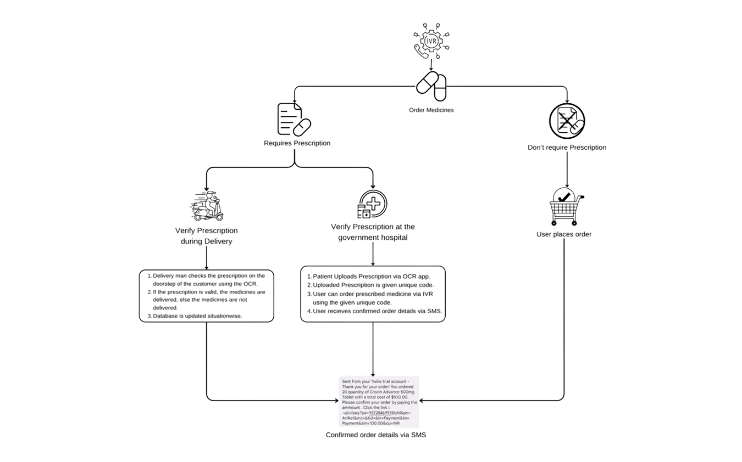

**Key Process Flow:**

1. **Order Initiation:**
   * Users interact with the IVR system to initiate a medicine order.
   * Users can provide a unique prescription code if they have a previous prescription on record.
2. **Prescription Validation:**
   * If a prescription code is available, the system retrieves the corresponding prescription details.
   * If no prescription is on file, a delivery partner will validate the physical prescription using OCR at the time of delivery.
3. **Healthcare Provider Review:**
   * The Fabric Client sends the prescription to a healthcare provider (doctor/hospital) for validation.
   * The provider checks the prescription’s legitimacy, ensuring it is valid, not expired, and the dosage is appropriate.
4. **Transaction Creation:**
   * After validation, the system creates a transaction that includes the medicine details, user information, and confirmation from the healthcare provider.
5. **Transaction Endorsement:**
   * Multiple network participants simulate the transaction to verify compliance with business rules.
   * Once validated, the transaction is endorsed and prepared for blockchain processing.
6. **Blockchain Recording:**
   * The endorsed transaction is organized into blocks and broadcasted to the network.
   * The blocks are committed to the blockchain, ensuring an immutable record of the transaction.
7. **Pharmacist Notification:**
   * The pharmacist is notified to prepare the medicines for dispatch.
   * Communication is maintained regarding stock availability and any discrepancies in the prescription.
8. **Delivery Coordination:**
   * The delivery partner is informed to pick up the medicines once they are ready.
   * The delivery partner verifies that the correct items are packed and ensures the inclusion of all relevant documents.
9. **Delivery Confirmation:**
   * The delivery partner updates the system with the delivery status.
   * Upon successful delivery, the transaction is recorded on the blockchain, closing the order loop.

**4.2. Modular design of the system:**

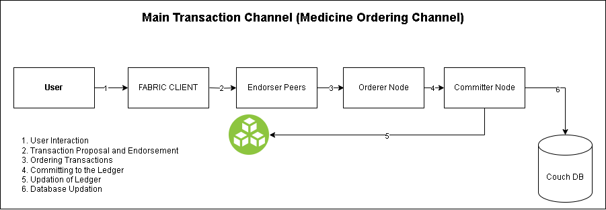

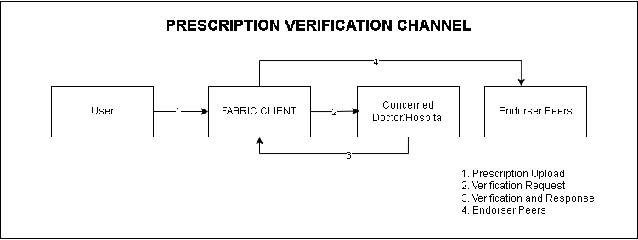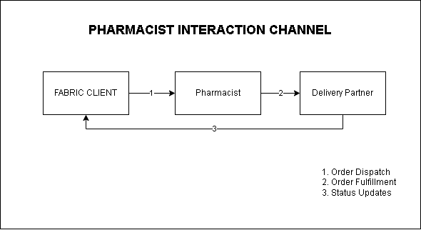

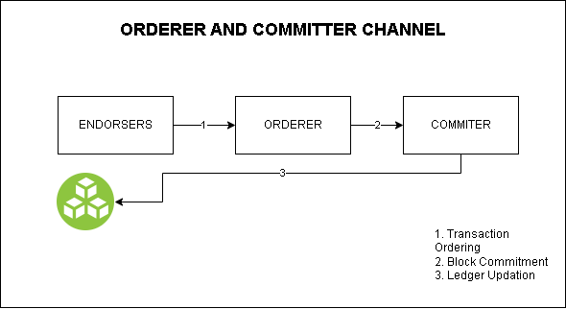

**A. User-IVR Channel**

The User-IVR Channel represents the interaction between the end user and the Interactive Voice Response (IVR) system. This channel is critical as it allows users, especially those in rural areas or without smartphones, to interact with the system via voice commands. When a user initiates a medicine order, the IVR system captures their input, whether it’s the selection of medicines or the submission of a prescription (when required). The IVR system uses voice prompts to gather additional information such as dosage and quantity, ensuring that all necessary details are collected for the order. Once the user’s request is received, the IVR transfers this data to the Fabric Client for further processing as shown in Figure 4.

This channel plays a key role in ensuring accessibility, allowing users who are not familiar with complex digital interfaces to place orders using a simple voice-driven system. It acts as the entry point into the entire blockchain-based transaction flow.

**B. IVR-Fabric Client Channel**

The IVR-Fabric Client Channel serves as the communication link between the IVR system and the Fabric Client, which is responsible for managing backend interactions and the blockchain. Once the IVR system collects the necessary order and prescription data, it transfers this information to the Fabric Client. In this channel, the Fabric Client processes the data received from the IVR system, validates user inputs, and coordinates further actions such as sending prescription verification requests to the doctor or healthcare provider.

This channel ensures that all user requests initiated via the IVR are seamlessly integrated into the blockchain network. The Fabric Client serves as the mediator, linking the front-end user interactions with the decentralized blockchain infrastructure.

**C. Fabric Client-Doctor/Hospital Channel**

The Fabric Client-Doctor/Hospital Channel facilitates communication between the Fabric Client and the healthcare providers involved in validating prescriptions. Once a prescription is submitted by the user, the Fabric Client sends it to the concerned doctor or hospital for validation. The doctor verifies the prescription’s authenticity, ensuring it is not expired and that the prescribed medication dosage is appropriate for the patient. After reviewing the prescription, the doctor/hospital communicates the validation results back to the Fabric Client through this channel.This channel plays a vital role in maintaining the safety and legitimacy of the medicines being dispensed, ensuring that only validated prescriptions proceed to the next stage of processing.

**D. Fabric Client-Endorser Peer Channel**

The Fabric Client-Endorser Peer Channel is essential for the validation of transactions in the blockchain. After the prescription is verified, the Fabric Client creates a transaction that includes the order details and sends it to the endorser peers within the blockchain network. The endorser peers execute the chaincode (smart contracts) to verify that the transaction complies with the system’s business logic, such as checking prescription validity, medicine availability, and dosage limits. After simulating the transaction (a ‘dry run’), the endorser peers return an endorsement if the transaction is deemed valid.

**E. Fabric Client-Orderer Node Channel**

The Fabric Client-Orderer Node Channel handles the submission of endorsed transactions for final ordering and block creation. After receiving endorsements from the peers, the Fabric Client sends the endorsed transaction to the Orderer Node, which organizes the transactions into blocks. These blocks are created sequentially, ensuring that all transactions are consistently ordered across the network. Once the blocks are formed, they are sent to all peers for commitment.This channel is critical for maintaining the ordering of transactions across the decentralized network, ensuring that the blockchain remains synchronized and consistent.

**F. Orderer Node-Committer Node Channel**

The Orderer Node-Committer Node Channel handles the distribution of ordered blocks to the committing peers in the blockchain network. After the Orderer Node packages the transactions into blocks, it broadcasts them to the Committer Nodes. The Committer Nodes verify that each block contains valid transactions with sufficient endorsements and then commit the block to their local ledger. Additionally, the Committer Nodes update the World State (CouchDB) to reflect the latest transaction states.This channel ensures that all transactions are permanently recorded in the blockchain ledger, finalizing the medicine order and prescription records. It also keeps the decentralized ledger up-to-date across all participating nodes.

**G. Fabric Client-Pharmacist Channel**

The Fabric Client-Pharmacist Channel enables communication between the Fabric Client and the Pharmacist. Once a transaction has been successfully committed to the blockchain, the Fabric Client notifies the Pharmacist that the order is valid and ready for fulfillment. The pharmacist then reviews the order details, such as the prescribed medicine, dosage, and quantity, and prepares the medicine for dispatch. This channel also handles any communication regarding stock availability or discrepancies in the prescription.Through this channel, the pharmacist remains in sync with the blockchain-based order system, ensuring accurate fulfillment and preparation of medicine orders

**H. Fabric Client-Delivery Partner Channel**

The Fabric Client-Delivery Partner Channel handles the final stage of the order process—delivering the medicine to the user. Once the Pharmacist confirms that the medicine is ready for dispatch, the Fabric Client notifies the Delivery Partner, providing the necessary details about the pickup location, medicines, and delivery instructions. The Delivery Partner then coordinates with the pharmacist and ensures that the correct medicine is collected and delivered to the user. The Delivery Partner updates the Fabric Client with the delivery status, ensuring real-time tracking of the medicine delivery. This channel ensures smooth logistics and timely 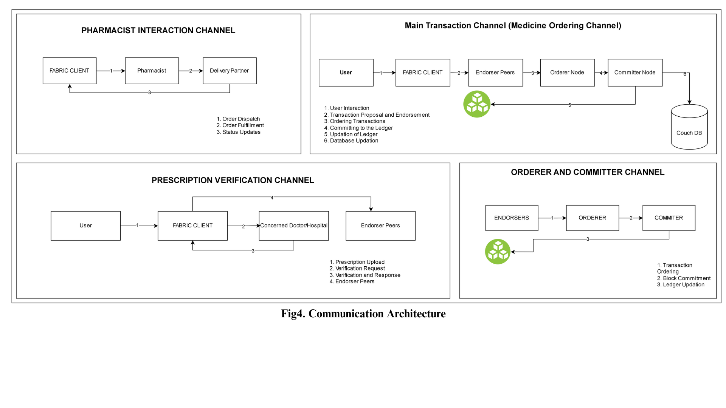delivery, closing the loop in the medicine ordering process.

**4.3. Detailed Design**

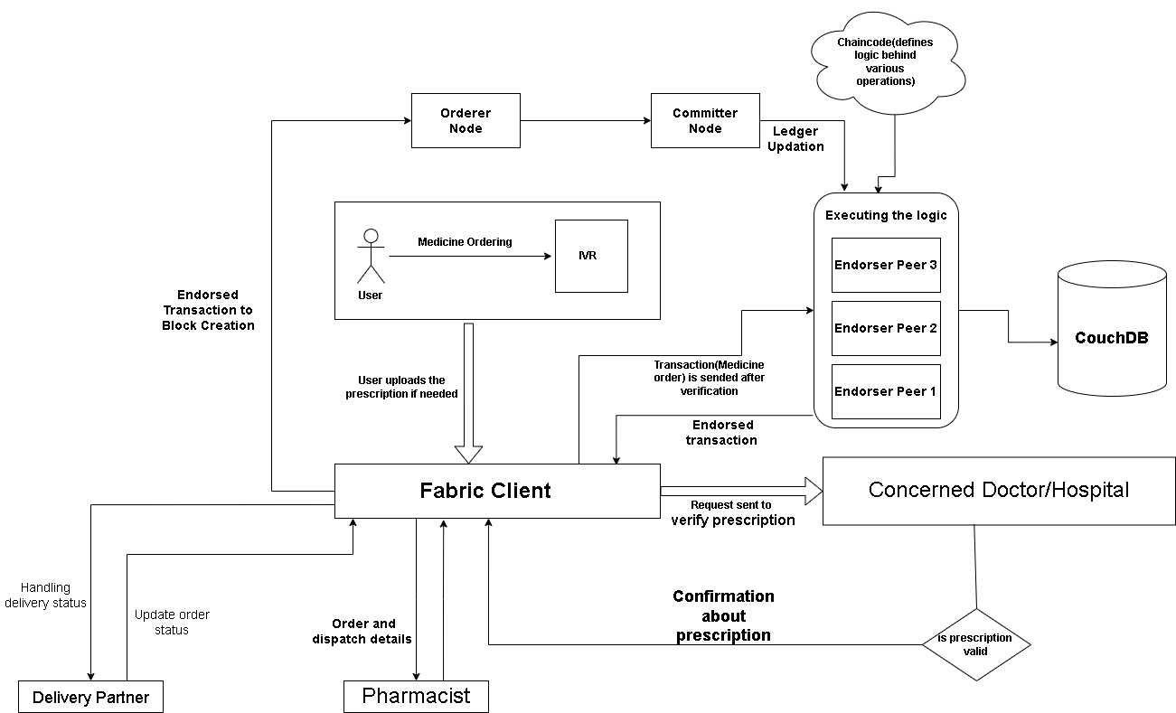

**Chapter 5: Implementation of the Proposed System**

**5.1.Methodology employed for development:**

The development of our Blockchain-based Medicine Ordering System (IMOS) follows a structured, modular, and iterative methodology, ensuring scalability, security, and real-time accessibility. The process incorporates modern software engineering practices, with a special focus on decentralized architecture and healthcare compliance.

#### 1. Requirement Gathering and System Design

* Conducted stakeholder interviews (patients, doctors, pharmacists, and delivery agents) to identify pain points in existing medicine ordering workflows.
* Defined functional requirements like prescription verification, medicine ordering, and real-time tracking.
* Created high-level architecture using component diagrams to represent channels (Patient–Doctor, Patient–Pharmacist, etc.).

#### 2. Technology Stack Selection

* **Blockchain Layer**: Hyperledger Fabric chosen for its permissioned, modular architecture and support for private transactions.
* **Voice Interface**: IVR system developed using Twilio/Exotel to facilitate voice-based ordering for non-digital users.
* **Backend**: Go (Golang) used for writing chaincode (smart contracts); Python for OCR and data processing tasks.
* **Data Storage**: MongoDB for storing OCR-extracted data and transaction metadata off-chain.
* **Message Queuing & Real-time Processing**: Apache Kafka used for streaming IVR data and facilitating asynchronous communication.

#### 3. Chaincode Development and Integration

* Developed Go-based smart contracts to record medicine orders, validate prescriptions, and update statuses.
* Implemented role-based access to ensure doctors, pharmacists, and delivery agents interact with only relevant transaction data.
* Configured Fabric channels for secure communication between concerned stakeholders.

#### 4. Prescription Validation and OCR Module

* Integrated Optical Character Recognition (OCR) to convert handwritten prescriptions into structured text.
* Applied NLP techniques to extract medicine names, dosage, and quantity from OCR output.
* Validated extracted data using predefined medical dictionaries and flagging ambiguous entries for doctor review.

#### 5. Transaction Workflow Implementation

* The IVR data is sent to the Fabric client which triggers a smart contract for prescription verification and medicine ordering.
* The endorsement policy of Fabric ensures that only valid transactions are simulated, endorsed, and committed.
* Doctor, pharmacist, and delivery partners interact with the system through role-specific endpoints or lightweight apps.

6**. Deployment and Scalability**

* Containerized components using Docker for easy deployment and scaling.
* Configured Hyperledger Fabric network with multiple peers and orderers to simulate a real-world multi-organization setup.
* Provisioned auto-scaling for IVR processing and OCR functions based on load.

**5.2.Algorithms and Flowcharts for the respective modules developed:**



**5.3.Datasets source and utilisation:**

For our system, we collected data primarily from Tata 1mg, one of India’s leading digital health platforms. The dataset includes crucial medical details such as medicine names, dosages, manufacturer names, pricing, and category classifications. This data serves as the foundational layer for various core functionalities of our system.

We utilized this dataset to support medicine recommendation logic, verify medicine authenticity, and enable dosage validation. The structured information also allows us to cross-reference prescriptions submitted through the IVR system, ensuring patients receive the correct medications. Furthermore, the dataset helps in mapping generic alternatives, checking stock availability with pharmacists, and maintaining standardized information across the blockchain network. This integration ensures accurate, efficient, and reliable medicine ordering and traceability throughout the system.

**Chapter 6: Results and Discussions**

**6.1.Screenshot of User Interface(UI) for the system:**

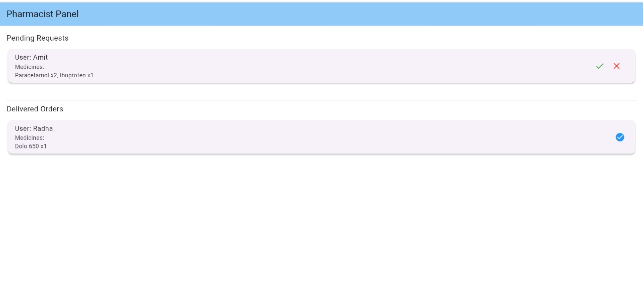

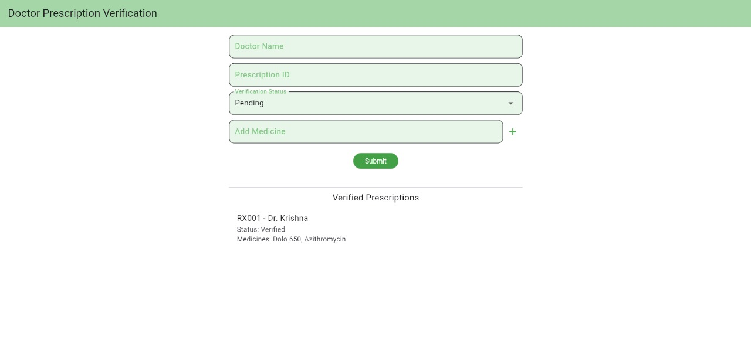

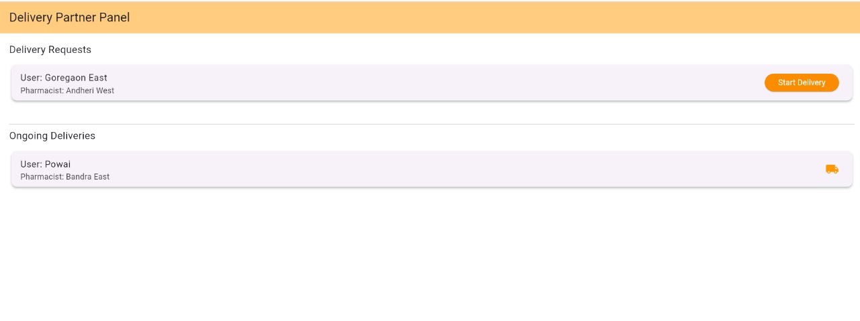

1. **Customer Interface:**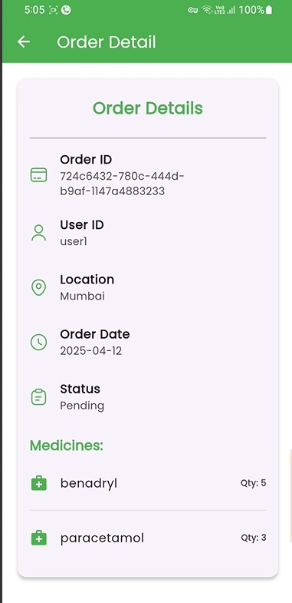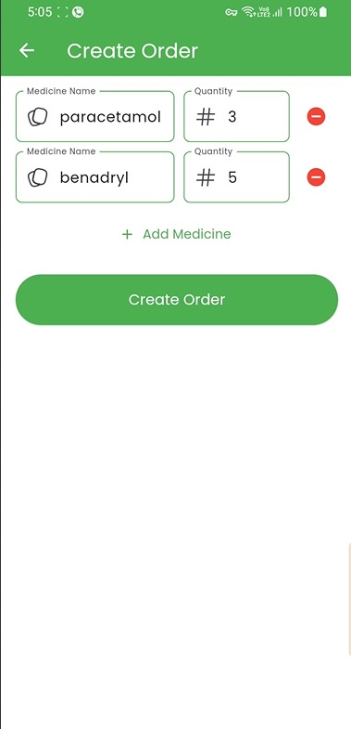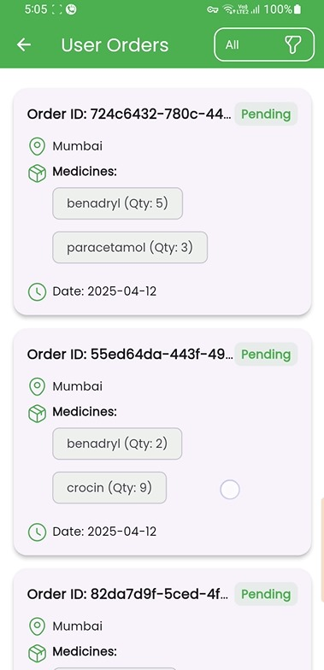

***Creating medicine order*** ***All orders by a user*** ***Individual order screen***

**Chapter 7: Conclusion**

**7.1.Limitations:**

* No real-time video consultation or follow-up with doctors.
* Limited personalization due to lack of historical patient data analysis.
* Voice-based input may be inaccurate in noisy environments.
* Lacks support for complex prescriptions requiring in-person diagnosis.

**7.2.Conclusion:**

The **IMOSB** is designed to bridge the healthcare accessibility gap, especially in rural or digitally underserved regions. It enables patients to order medicines through a voice-enabled IVR system without the need for internet access or smartphones. Patients submit their prescriptions verbally or in digitized form, which are then verified by certified doctors to ensure authenticity. Approved prescriptions are processed by pharmacists, and medicines are delivered by agents — all while maintaining a secure, tamper-proof record on a blockchain network. The system also provides voice and SMS-based updates for complete transparency.

This platform not only ensures end-to-end traceability and data integrity but also supports alternative or generic medicine recommendations using stored medical data. By connecting doctors, pharmacists, patients, and delivery partners on a decentralized network, it minimizes fraud, ensures prescription validity, and enhances service efficiency. Future enhancements can include multilingual support, predictive analytics, and intelligent inventory management, making the system more robust and patient-centric.

**7.3.Future Scope:**

In the future, our vision is to develop a sophisticated and comprehensive Interactive Voice Response (IVR) system that transcends its current capabilities. Our goal is to create an IVR system that can not only read prescriptions accurately but also provide valuable medical advice and seamlessly place medication orders for users. We aim to leverage advanced artificial intelligence and natural language processing technologies to ensure the highest level of accuracy, user-friendliness, and reliability in the healthcare domain. This expanded IVR system will serve as a trusted healthcare companion, offering expert guidance, personalized recommendations, and a convenient platform for secure and efficient medication procurement, ultimately enhancing the well-being and health management of our users.

**References**

**Journal Papers:**

[1] N. Iqbal, F. Jamil, S. Ahmad and D. Kim, “A novel blockchain-based integrity and reliable veterinary clinic information management system using predictive analytics for provisioning of quality health services,” *IEEE Access*, vol. 9, pp. 8069–8098, 2021, doi: 10.1109/ACCESS.2021.3049325.

[2] S. Wang, J. Wang, X. Wang, T. Qiu, Y. Yuan, L. Ouyang, Y. Guo and F.-Y. Wang, “Blockchain-powered parallel healthcare systems based on the ACP approach,” *IEEE Trans. Comput. Soc. Syst.*, vol. 5, no. 4, pp. 942–950, 2018, doi: 10.1109/TCSS.2018.2865526.

[3] K. Fan, S. Wang, Y. Ren, J. Li and Y. Yang, “MedBlock: Efficient and secure medical data sharing via blockchain,” *J. Med. Syst.*, vol. 42, no. 136, 2018, doi: 10.1007/s10916-018-0993-7.

**Conference Proceedings:**

[4] A. Azaria, A. Ekblaw, T. Vieira and A. Lippman, “MedRec: Using blockchain for medical data access and permission management,” in *Proc. 2nd Int. Conf. Open Big Data (OBD)*, Vienna, Austria, 2016, pp. 25–30, doi: 10.1109/OBD.2016.11.

[5] P. K. Kushwaha and M. Kumaresan, “Machine learning algorithm in healthcare system: A review,” in *Proc. 2021 Int. Conf. Technol. Advancements Innovations (ICTAI)*, Tashkent, Uzbekistan, 2021, pp. 478–481, doi: 10.1109/ICTAI53771.2021.9673220.

[6] M. Soujanya and S. Kumar, “Personalized IVR system in contact center,” in *Proc. 2010 Int. Conf. Electron. Inf. Eng.*, Kyoto, Japan, 2010, vol. 1, no. 457, doi: 10.1109/ICEIE.2010.5559673.

**Websites:**

[7] European Medicines Agency, “Medicines,” [Online]. Available:<https://www.ema.europa.eu/en/medicines/field_ema_web_categories%253Aname_field/Human>. [Accessed: Aug. 14, 2023].

[8] MediSearch, “MediSearch,” [Online]. Available:<https://medisearch.io/>. [Accessed: Aug. 24, 2023].

[9] National Library of Medicine, “NLM Products and Services,” [Online]. Available:<https://eresources.nlm.nih.gov/>. [Accessed: Aug. 14, 2023

**Appendix**

**1] Paper I details :-**

**a.Paper I :-**

The rapid growth of smartphones and digital devices has transformed how people access services worldwide. However, a significant portion of the population, particularly the elderly and those in rural areas, remains excluded from these advancements due to limited familiarity with modern technology. To address this, we propose the IVR-based Medicine Ordering System using Blockchain (IMOBS), which allows patients to order medicines using simple voice calls and natural language, eliminating the need for smartphones or technical expertise.Our system is designed with simplicity and accessibility at its core, allowing users to place orders through phone calls. This makes it especially useful for elderly individuals and those in rural or underserved areas, where internet access or smartphones might be unavailable. In our specific implementation, blockchain is used to enhance the security and transparency of the entire medicine ordering process. It ensures that once an order is placed, the transaction details, such as order history and supply chain information, are recorded on a secure, tamper-proof ledger. This guarantees the integrity of orders and ensures that medicines provided to patients are sourced from legitimate suppliers. By integrating blockchain, our system offers an added layer of trust, ensuring that medicines delivered to users are authentic and traceable without requiring the patient to interact with any complex digital system. Additionally, our system offers an added layer of trust, ensuring that medicines delivered to users are authentic and traceable without requiring the patient to interact with any complex digital system. Importantly, our system is designed to prevent counterfeit medicines from being made available, further safeguarding the health and well-being of our users.

**b. Certificate of publication**

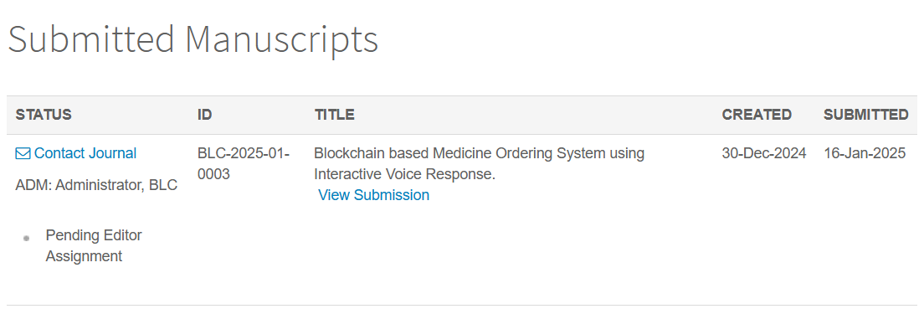

**c. Plagiarism report**

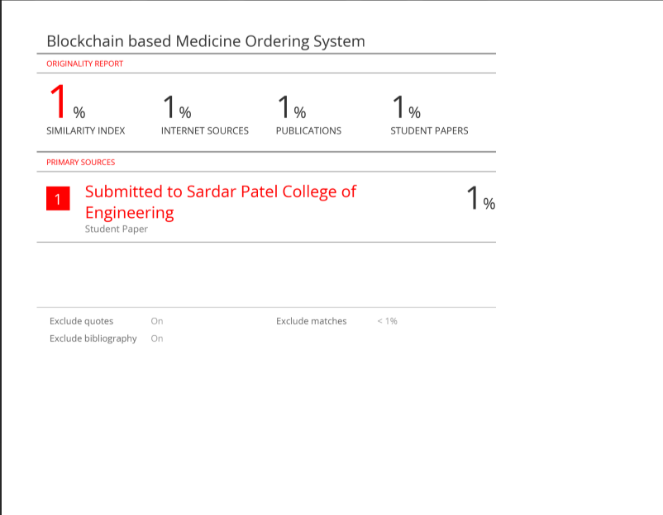

**c.Project review sheet ;**

**Project review sheet 1:**

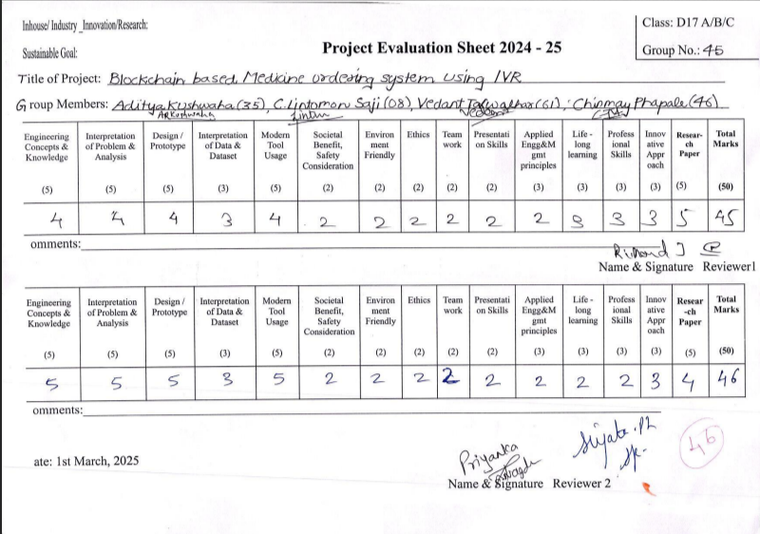

**Project review sheet 2**